**HOW TO LOGIN NC3 DB**

Step 1:

Login to SQL SERVER

[pp7864@lpp0fe01.noc.att.com](mailto:pp7864@lpp0fe01.noc.att.com)

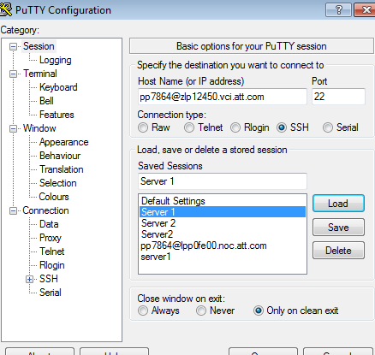

Step 2:

Enter the RSA token and enter

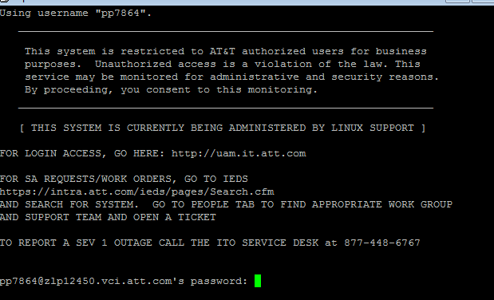

Step 3:

Enter to NC3 DB by command sudo su – nc3

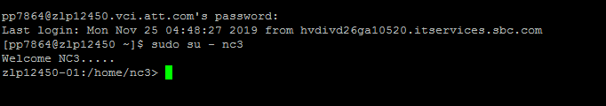

Step 4:

Now use the below command to enter SQL

/opt/app/nc3/sfw/oracle/product/11.2.0.4/bin/sqlplus [nc3/inte11nside345@p1c3d137.db.att.com](mailto:nc3/inte11nside345@p1c3d137.db.att.com)

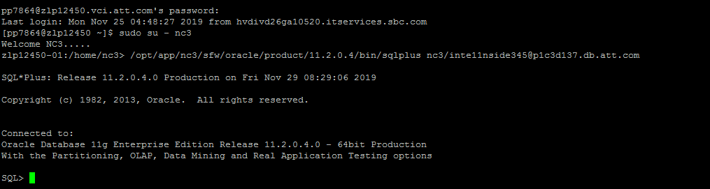

Note:

You can set the line and page size by following commands:

set linesize 5000;

set pagesize 5000;